

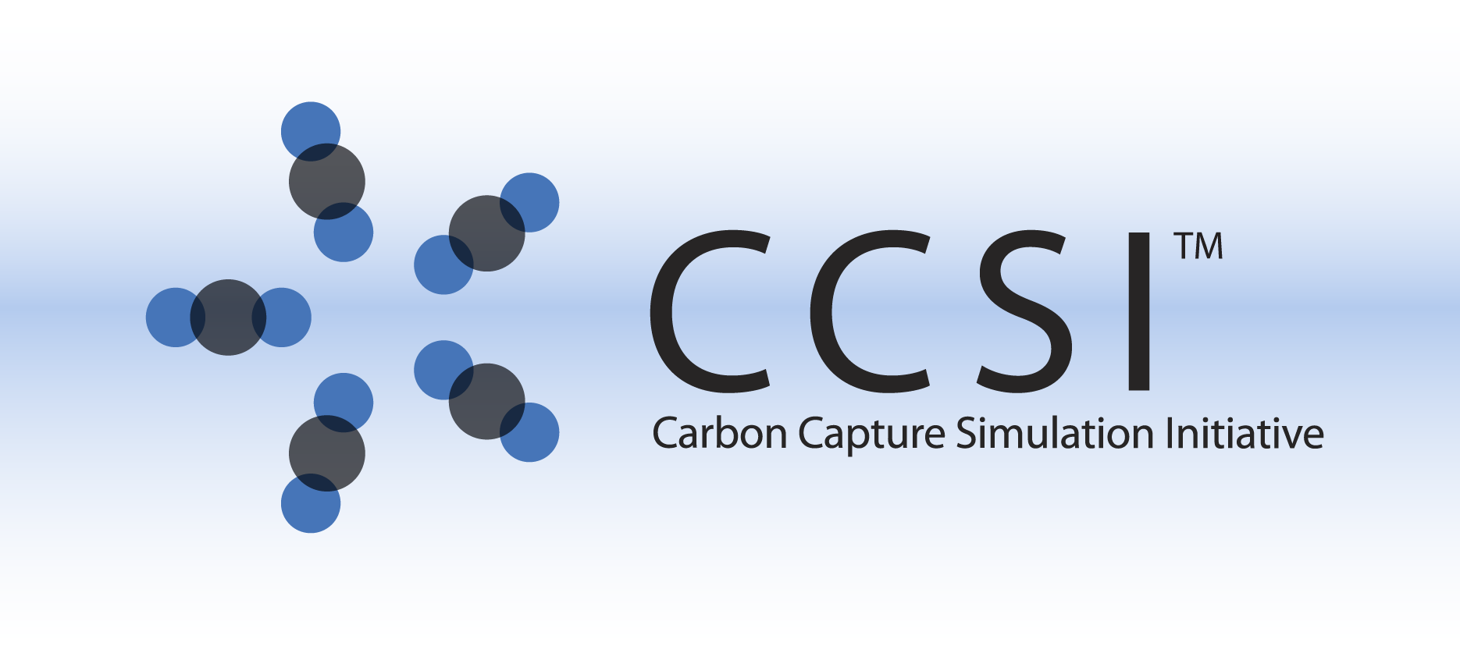

CCSI WWC

User Manual

Version 2.0.0

March 2018



Copyright (c) 2012 - 2018

**Copyright Notice**

WWC was produced under the DOE Carbon Capture Simulation Initiative (CCSI), and is copyright (c) 2012 - 2018 by the software owners: Oak Ridge Institute for Science and Education (ORISE), Los Alamos National Security, LLC., Lawrence Livermore National Security, LLC., The Regents of the University of California, through Lawrence Berkeley National Laboratory, Battelle Memorial Institute, Pacific Northwest Division through Pacific Northwest National Laboratory, Carnegie Mellon University, West Virginia University, Boston University, the Trustees of Princeton University, The University of Texas at Austin, URS Energy & Construction, Inc., et al.. All rights reserved.

NOTICE. This Software was developed under funding from the U.S. Department of Energy and the U.S. Government consequently retains certain rights. As such, the U.S. Government has been granted for itself and others acting on its behalf a paid-up, nonexclusive, irrevocable, worldwide license in the Software to reproduce, distribute copies to the public, prepare derivative works, and perform publicly and display publicly, and to permit other to do so.

**License Agreement**

WWC Copyright (c) 2012 - 2018, by the software owners: Oak Ridge Institute for Science and Education (ORISE), Los Alamos National Security, LLC., Lawrence Livermore National Security, LLC., The Regents of the University of California, through Lawrence Berkeley National Laboratory, Battelle Memorial Institute, Pacific Northwest Division through Pacific Northwest National Laboratory, Carnegie Mellon University, West Virginia University, Boston University, the Trustees of Princeton University, The University of Texas at Austin, URS Energy & Construction, Inc., et al. All rights reserved.

Redistribution and use in source and binary forms, with or without modification, are permitted provided that the following conditions are met:

1. Redistributions of source code must retain the above copyright notice, this list of conditions and the following disclaimer.
2. Redistributions in binary form must reproduce the above copyright notice, this list of conditions and the following disclaimer in the documentation and/or other materials provided with the distribution.
3. Neither the name of the Carbon Capture Simulation Initiative, U.S. Dept. of Energy, the National Energy Technology Laboratory, Oak Ridge Institute for Science and Education (ORISE), Los Alamos National Security, LLC., Lawrence Livermore National Security, LLC., the University of California, Lawrence Berkeley National Laboratory, Battelle Memorial Institute, Pacific Northwest National Laboratory, Carnegie Mellon University, West Virginia University, Boston University, the Trustees of Princeton University, the University of Texas at Austin, URS Energy & Construction, Inc., nor the names of its contributors may be used to endorse or promote products derived from this software without specific prior written permission.

THIS SOFTWARE IS PROVIDED BY THE COPYRIGHT HOLDERS AND CONTRIBUTORS "AS IS" AND ANY EXPRESS OR IMPLIED WARRANTIES, INCLUDING, BUT NOT LIMITED TO, THE IMPLIED WARRANTIES OF MERCHANTABILITY AND FITNESS FOR A PARTICULAR PURPOSE ARE DISCLAIMED. IN NO EVENT SHALL THE COPYRIGHT OWNER OR CONTRIBUTORS BE LIABLE FOR ANY DIRECT, INDIRECT, INCIDENTAL, SPECIAL, EXEMPLARY, OR CONSEQUENTIAL DAMAGES (INCLUDING, BUT NOT LIMITED TO, PROCUREMENT OF SUBSTITUTE GOODS OR SERVICES; LOSS OF USE, DATA, OR PROFITS; OR BUSINESS INTERRUPTION) HOWEVER CAUSED AND ON ANY THEORY OF LIABILITY, WHETHER IN CONTRACT, STRICT LIABILITY, OR TORT (INCLUDING NEGLIGENCE OR OTHERWISE) ARISING IN ANY WAY OUT OF THE USE OF THIS SOFTWARE, EVEN IF ADVISED OF THE POSSIBILITY OF SUCH DAMAGE.

You are under no obligation whatsoever to provide any bug fixes, patches, or upgrades to the features, functionality or performance of the source code ("Enhancements") to anyone; however, if you choose to make your Enhancements available either publicly, or directly to Lawrence Berkeley National Laboratory, without imposing a separate written license agreement for such Enhancements, then you hereby grant the following license: a non-exclusive, royalty-free perpetual license to install, use, modify, prepare derivative works, incorporate into other computer software, distribute, and sublicense such enhancements or derivative works thereof, in binary and source code form. This material was produced under the DOE Carbon Capture Simulation

Table of Contents

OpenFOAM Wetted Wall Simulation Package 4

1.0 Introduction 4

2.0 Installation 4

2.1 Prerequisites 4

2.1.1 Hardware 4

2.1.2 Software 4

2.2 Third Party Software 5

2.3 Product Installation 5

3.0 Simulations 6

3.1 Input File 6

3.2 Output 7

3.3 Post-Processing 7

3.4 Overall Simulation Procedure Summary 8

4.0 Theoretical Background 9

5.0 Case Study 10

5.1 Geometry 11

5.2 Boundary and Initial Conditions 11

5.3 Run in Serial or Parallel 12

6.0 Reporting Issues 12

7.0 References 13

List of Figures

Figure 1: Input directories and files. 6

Figure 2: Schematic picture of the geometry. 10

List of Tables

Table 1: Values of Input Parameters 12

To obtain support for the products within this package, please send an e-mail to   
[ccsi-support@acceleratecarboncapture.org](mailto:ccsi-support@acceleratecarboncapture.org).

OpenFOAM Wetted Wall Simulation Package

1. Introduction

CCSI aims to develop state-of-the-art computational modeling and simulation tools to accelerate the commercialization of carbon capture technologies from discovery to development, and eventually the widespread deployment to hundreds of power plants, through a partnership among national laboratories, industry and academic institutions. The ultimate goal of CCSI Toolset is to provide end users in industry with a comprehensive, integrated suite of scientifically validated models, delivering uncertainty quantification, optimization, risk analysis and decision making capabilities [1].

This user manual contains the installation guides, theoretical background, and one case study for the CFD model developed to simulate the hydrodynamics of falling film in wetted wall column, coupled with mass transfer and absorption of gas species. The liquid falling film contains aqueous solutions of ethanolamine (MEA) used as a CO2 stream scrubbing [liquid](https://en.wikipedia.org/wiki/Liquid). The fundamental physical and chemical processes behind this is: CO2 is absorbed and removed from the exhaust of coal- and gas-fired [power plants](https://en.wikipedia.org/wiki/Power_plant) by chemical reactions through scrubbing processes using highly CO2 soluble and reactive solvent, MEA.

The multiphase CFD models fully equipped with chemistry and mass transport capabilities are established to predict the overall CO2 mass transfer rate. The models are built upon OpenFOAM (Open source Field Operation and Manipulation), a C++ toolbox for the development of customized numerical solvers, and pre-/post-processing utilities for the solution of continuum mechanics problems, including computational fluid dynamics (CFD). In the case study, the key input parameters and output variables will be identified.

1. Installation

CCSI wetted wall simulations are custom OpenFOAM simulations. For that reason, the general installation procedure in this user manual follows that of OpenFOAM [2]. **Note:** The version of OpenFOAM needs to be 2.2.0. In this session, only the wetted wall model package installation procedure will be covered in details. The general OpenFOAM steps can be referred to the OpenFOAM manual.

* 1. Prerequisites
     1. Hardware

The hardware requirements for this CCSI model follow exactly the same as that for OpenFOAM. OpenFOAM is only supported on UNIX/LINUX platform, therefore a UNIX/LINUX server or system is required to install, build, and run the simulation.

* + 1. Software

The software requirements for wetted wall simulation follow that of OpenFOAM as well. A C++ compiler for the given platform is required for the compilation. Compilation has been tested with the following C++ compilers and versions:

* GCC: 4.5.0 and above
* LLVM Clang: 3.4 and above
* Intel ICC: 14.0.1
  1. Third Party Software

Open-source, multi-platform data analysis and visualization application ParaView is recommended for the OpenFOAM simulation post-processing purpose. Users can download ParaView software online from <http://www.paraview.org/>.

* 1. Product Installation

It is assumed that users have downloaded OpenFOAM source files, set environment variables, and built the sources under $InstallDir/OpenFOAM. This session will only describe the steps to build CFD models for CCSI wetted wall column package.

Custom code for CCSI wetted wall column simulation are available on this site: <https://github.com/CCSI-Tool>set/WWC.

Create a directory for CCSI wetted wall column package, for example, in LINUX, $HOME/CCSI/WWC. Once obtaining WWC directory from the above CCSI site, the WWC directory should include the following folders and files:

**Make**

Allwclean

Allwmake

alphaCourantNo.H

alphaEqn.H

alphaEqnSubCycle.H

c1Eqn.H

c2Eqn.H

c3Eqn.H

correctPhi.H

createFileds.H

interFoam.C

interFoam.dep

Makef

pEqn.H

setDeltaT.H

UEqn.H

**Note:** **Make** is a folder and the rest of them are files.

Copy the **wmake** folder from the OpenFOAM root directory to the WWC directory by simply typing the following command.

cp –r $InstallDir/OpenFOAM/wmake $HOME/CCSI/WWC/

To keep the root directories intact and implement the wetted wall model package as an individual solver library, a new environment path needs to be set. Type the following commands:

export WM_DIR=$HOME/CCSI/WWC/wmake

export FOAM_USER_APPBIN=$WM_DIR

In the wetted wall column directory (e.g., $HOME/CCSI/WWC), type wmake to build the model. The building process will compile object files in $HOME/CCSI/WWC directory and generate an executable interFoam file there. This interFoam file can be copied to the user’s project directory and serve as an execute command to run the corresponding project. Alternatively, users can also refer to this directory ($HOME/CCSI/WWC) to run interFoam for their own project. See the case study for details.

**Note:** This new executable interFoam is not the same as that from the OpenFOAM interFoam solver because the new created interFoam has the capability to simulate both hydrodynamics and chemical reaction of gas-liquid flow. To avoid any confusion, the user may choose to rename the new generated interFoam to e.g., CCSI_interFoam.

1. Simulations

Users can choose serial execution or parallel execution to run a CCSI wetted wall CFD simulation. The case study in Section 5.0 Case Study will provide guidance for parallel simulation. Users can also refer to Section 3.4 of OpenFOAM User Guide [3] to get more information. In this session, we provide a brief introduction on the input file, output files, and the post-processing.

* 1. Input File

The same as all other OpenFOAM input files, the system reads input data files from three sub-directories when a.out runs. The data may vary case by case, but the key parameters specified in the corresponding input files are listed in the hierarchical chart as shown in Figure 34.

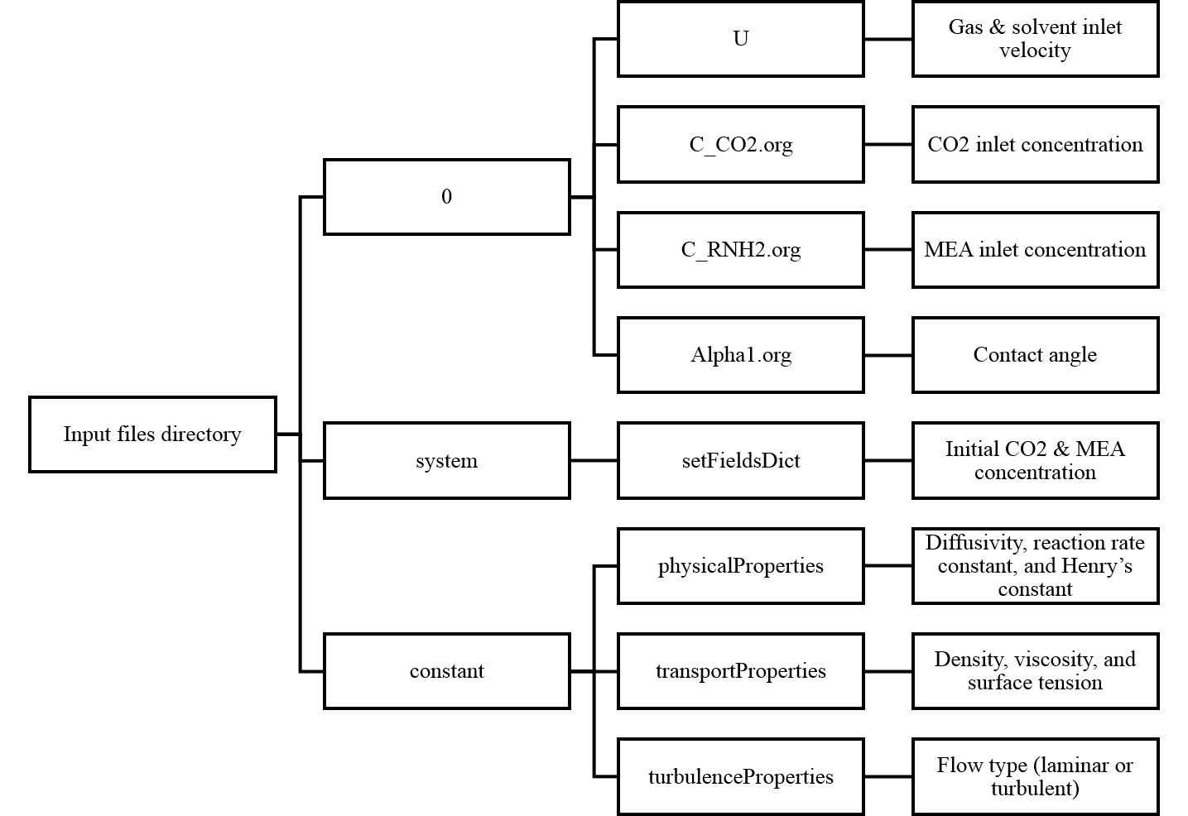

Figure 1: Input directories and files.

* In the 0 directory, solvent inlet and gas inlet velocity can be edited in U file, CO2 inlet concentration can be edited in c_CO2.org file, MEA inlet concentration can be edited in c_RNH2.org file, and contact angle can be edited in alpha1.org file.
* In the constant directory, user can choose to edit the modified Henry’s constant (reciprocal of the original Henry’s constant value), reaction rate constant, CO2 diffusivity in solvent, MEA diffusivity in solvent, CO2 diffusivity in gas mixture, etc., in physicalProperties file. In addition, user can also choose to edit density and viscosity of the liquid and gas phase, as well as the surface tension in transportProperties file. Furthermore, user can select laminar or turbulent modelling in turbulenceProperties file.
* In the system directory, initial condition of the CO2 and MEA concentration can be set in setFieldsDict file.

**Note:** All parameters are well commented for the sample input files.

Sample input files, which is also the case study input files can be downloaded from the CCSI site: <https://github.com/CCSI-Toolset/WWC>.

* 1. Output

OpenFOAM output containing the data of volume of fraction, CO2 and MEA concentration, velocity, pressure, etc., throughout the domain is stored in every time output directories.

* 1. Post-Processing

Users can use ParaView, or their own preferred tools to do post-processing analysis with their simulation results. To open a case directly from ParaView, the user creates a dummy file with the extension .OpenFOAM. See details from OpenFOAM User Guide [3].

* 1. Overall Simulation Procedure Summary
* Download and install the OpenFOAM software

[http://www.openfoam.org/download](http://www.openfoam.org/download/)

* Download the wetted wall column custom code

<https://github.com/CCSI-Toolset/WWC>

* Copy the wmake directory from OpenFOAM root directory to WWC directory

cp –r $InstallDir/OpenFOAM/wmake $HOME/CCSI/WWC/

* Set up environment path

export WM_DIR=$HOME/CCSI/WWM/wmake

export FOAM_USER_APPBIN=$WM_DIR

* Compile Wetted Wall Column package

wmake

* Setup case and adjust the corresponding parameters based on users need (follow the OpenFOAM User Guide [3])
* Run case

interFoam

* Post-processing analysis (e.g., in ParaView)

1. Theoretical Background

VOF model will be employed to solve for two Newtonian, incompressible, isothermal, and immiscible fluids by tracking the volume fraction ($α$) of each phase in the volume fraction equation. The volume fraction equation is introduced as

|  |  |  |
| --- | --- | --- |
|  | $$\frac{∂}{∂t}\left(α_{L}\right)+∇∙\left(α_{L}u\right)=0$$ | (1) |

where $u=\left(u,v,w\right)$, denotes the velocity in x, y, and z direction, respectively. The subscript $L$ represent the liquid phase property. The gas phase volume fraction $α_{g}$ can then be calculated as

|  |  |  |
| --- | --- | --- |
|  | $α_{g}=1-α_{L}$. | (2) |

where the subscript g represents gas phase property.

The continuity and Naiver-Stocks equations are given by

|  |  |  |
| --- | --- | --- |
|  | $$\frac{∂ρ}{∂t}+∇∙\left(ρu\right)=0$$ | (3) |
|  | $$\frac{∂}{∂t}\left(ρu\right)+∇∙\left(ρuu\right)=-∇p+∇∙\left[μ\left(∇u+{∇u}^{T}\right)\right]+ρg-F_{st}$$ | (4) |

where density $ρ$ and viscosity $μ$ can be defined by a volume fraction averaged form as

|  |  |  |
| --- | --- | --- |
|  | $$ρ=α_{L}ρ_{L}+α_{g}ρ_{g}$$ | (5) |
|  | $$μ=α_{L}μ_{L}+α_{g}μ_{g}$$ | (6) |

$F_{st}$, the surface tension force, can be expressed using the CSF model proposed by Brackbill et al. [4].

|  |  |  |
| --- | --- | --- |
|  | $$F_{st}=σ_{st}κδn$$ | (7) |

where $σ_{st}$ is the surface tension coefficient, $κ=-∇∙n$ represents the curvature of the surface, $δ$ is the interface Dirac delta function, and $n$ is the interface normal vector.

The one-fluid equation [5] taking convection, diffusion, and interface mass transport into account will be applied to calculate gas concentration in both phases using only one equation throughout the domain.

|  |  |  |
| --- | --- | --- |
|  | $$\frac{∂c_{j}}{∂t}+∇∙\left(uc_{j}-D_{j}∇c_{j}-Γ_{j}\right)-W_{j}=0$$ | (8) |

with

$$Γ_{j}=-D_{j}\frac{c_{j}\left(1-k_{H,j}\right)}{α_{L}+k_{H,j}\left(1-α_{L}\right)}∇α_{L}$$

$$D=\frac{D_{L}D_{g}}{α_{L}D_{g}+\left(1-α_{L}\right)D_{L}}$$

where $c_{j}$ represents the concentration for gas species $j$, $D$ is the local diffusivity computed by the harmonic interpolation, and $k_{H}$ denotes the dimensionless Henry’s constant ($k_{H}=c_{g}/c_{L}$).

**Note:** The concentration of gas and liquid phase normally has a discontinuous jump at the interface caused by different solubility within the respective fluid phases. The term ($Γ_{j}$) in Equation (8) accounts for this behavior by taking the Henry’s Law into consideration. By applying the above equation, the concentration of oxygen can be computed as discontinuous across the interface. The last term ($W_{j}$) in Equation (8) is the production term related to the chemical reaction rate.

The chemical reaction of CO2 absorption by MEA can be expressed as

$$CO_{2}+2RNH_{2}→RNHCOO^{-}+RNH_{3}^{+}$$

where $R=-CH_{2}CH_{2}OH$. The reaction rate constant $k (l/mol∙s)$ is calculated based on the correlation proposed by Hikita et al. [6]

|  |  |  |
| --- | --- | --- |
|  | $$\log_{10}{k}=10.99-2152/T$$ | (9) |

After that, the reaction rate of CO2 can be calculated as

|  |  |  |
| --- | --- | --- |
|  | $$W_{CO_{2}}=kc_{CO_{2}}c_{MEA}$$ | (10) |

To simulate a non-reactive gas absorption across liquid film, the user can set the reaction rate constant $k$ to be zero to drop the $W$ term in Equation (8).

1. Case Study

In this section, we will set an example, CO2 mass transfer across MEA film, to explain how input files are created for what conditions: initial condition, boundary condition, and operating condition (temperature, pressure, etc.).

The case study input files, which are the same as the sample files shown in Section 3.1 Input File, can be downloaded from the CCSI site: <https://github.com/CCSI-Toolset/WWC>.



Figure 2: Schematic picture of the geometry.

* 1. Geometry

As shown in Figure 35, the geometry of this example is designed to be a 2-D flat plane. The x-axis denotes the thickness of the film layers perpendicular to the plate wall. The y-axis describes the   
stream-wise direction of the vertical film along the wall. The oxygen gas flows countercurrently with water solvent throughout the domain. The length of the geometry, $L$, is 90.9 mm and the width, $W$, is 5.25 mm. Inlet and outlet sizes for gas are set to be 0.1 mm. The solvent inlet is chosen to be 1mm, while the solvent outlet is set to be 2 mm.

If users choose to download the case study files under the directory of $HOME/CCSI/CASE, then the geometry information is stored in $HOME/CCSI/CASE/constant/polyMesh/blockMeshDict.

* 1. Boundary and Initial Conditions

Table 3 lists all the parameters used in the computational calculation. The boundary condition for the left, right, bottom and up walls is set to be non-slip condition.

At solvent inlet, MEA velocity is given as 0.1768m/s so that the type of flow will be laminar.

At solvent outlet, mass concentration gradient is given at zero because the flow is assumed to be at a fully developed condition.

|  |  |  |
| --- | --- | --- |
|  | $$\frac{dc}{dy}=0$$ | (11) |

For gas inlet, 0.1 mol/m3 CO2 gas is released to the domain at the velocity of $0.2317m/s$.

For incompressible flow, relative pressure (pressure difference) rather than the absolute pressure is more important. Therefore, the pressure value at gas outlet is set to be zero.

|  |  |  |
| --- | --- | --- |
|  | $$p=0$$ | (12) |

For initial conditions, the testing domain is placed at zero atm pressure and the domain is filled with 0.1 mol/m3 CO2 gas. The time step size is adjusted to be 1e-5 s for the simulation. The case is initially set to run for 0.5 seconds. The grid number is set to be 200 and 500 in x and y direction, respectively.

Table 1: Values of Input Parameters

| Parameters | Value and Unit |
| --- | --- |
| Temperature | 25°C |
| Pressure | 0 atm |
| Solvent Inlet Velocity | 0.1768m/s |
| Gas Inlet Velocity | 0.2317m/s |
| Inlet CO2 Concentration | 0.1mol/m3 |
| CO2 Diffusivity in Gas | 1.6e-5m2/s |
| CO2 Diffusivity in Solvent | 1.0e-9m2/s |
| MEA Diffusivity in Solvent | 1.0e-9m2/s |
| RNHCOO Diffusivity in Solvent | 1.0e-9m2/s |
| Solvent Contact Angle | 40 |
| Density (Solvent, Gas) | 1000,1 kg/m3 |
| Kinematic Viscosity (Solvent, Gas) | 3e-6, 1.48e-5 m2/s |
| Surface Tension | 0.07 kg/s2 |
| Henrys Constant of CO2 in MEA | 0.4669 (code use 1/0.4669=2.1418) |
| Reaction Rate Constant | 5.9178 m3/mol s |

* 1. Run in Serial or Parallel

The default setting in OpenFOAM is to run simulation in serial. This example shows how to run simulation in parallel. First of all, the detailed parameters regarding the decomposition of geometry and fields need to be specified in $HOME/CCSI/CASE/system/decomposeParDict. Then execute the decomposition using command decomposePar and finally run the case by simply typing the following command in the case study directory.

mpirun –np 16 $HOME/CCSI/WWC/interFoam -parallel > run.txt

In the case study, 16 cores are used to run the simulation. In addition, the executable file interFoam is obtained from the download directory of wetted wall model package. **Note:** To run simulation in parallel, the OpenMPI library also need to be installed to the UNIX/LINUX system.

1. Reporting Issues

Send an e-mail to [ccsi-support@acceleratecarboncapture.org](mailto:ccsi-support@acceleratecarboncapture.org) to report a CCSI wetted wall model specific issue.

1. References

[1] PNNL ARRA Report on the Development of Full Scale CFD Simulations of a Solid Sorbent Adsorber and Regenerator and the Development of an Approach for UQ of CFD Simulations, CCSI, February 24, 2012, DOE and NETL.

[2] OpenFOAM – Open source Field Operation and Manipulation, Version OpenFOAM 2.2.0. Download available <http://www.openfoam.org/download/>.

[3] OpenFOAM User Guide <http://cfd.direct/openfoam/user-guide/>.

[4] Brackbill, J.U., D.B. Kothe, and C. Zemach, A Continuum Method for Modeling   
Surface-Tension. Journal of Computational Physics, 1992. 100(2): p. 335–354.

[5] Haroun, Y., D. Legendre, and L. Raynal, Direct numerical simulation of reactive absorption in gas-liquid flow on structured packing using interface capturing method. Chemical Engineering Science, 2010. 65(1): p. 351–356.

[6] H. Hikita, S. Asai, H. Ishikawa, M. Honda, The kinetics of reactions of carbon dioxide with monoethanolamine, diethanolamine and triethanolamine by a rapid mixing method, Chem. Eng. J. 13 (1977) 7–12.